PRESS RELEASE

COMMUNICATIONS AND MEDIA TEAM OF THE ASEAN SUMMIT 2023

No.75/SP/TKM-ASEAN2023/ENG/5/2023

With President Jokowi as Chair, ASEAN Discusses Follow-up of Five-Point Consensus in Myanmar

West Manggarai, May 11, 2023 - Indonesian President Joko Widodo (Jokowi) chaired the Retreat session of the 42nd ASEAN Summit in 2023 on the second day of the Summit. The meeting, which took place at the Meruorah Hotel, Labuan Bajo, West Manggarai, East Nusa Tenggara, Thursday (11/05/2023) morning discussed two important issues, namely the review of the implementation of the Five-Point Consensus in Myanmar and the ASEAN Outlook on the Indo-Pacific (AOIP).

Regarding the situation in Myanmar, President Jokowi stressed that as a country that holds the chairmanship of ASEAN, Indonesia continues to push for progress on the implementation of the Five-Point Consensus.

“I must speak candidly. On Implementation of the 5PC, there has not been significant progress. Therefore, ASEAN unity is required to decide on the next steps,” said the President.

In addition, the President also reiterated the need for dialogue and an end to violence in Myanmar. Together with relevant parties, the President added that Indonesia also continues to facilitate humanitarian assistance for the people in Myanmar.

“… through engagements with various parties urge for an inclusive dialogue, call for the cessation of violence, facilitate conclusion of the Joint Needs Assesment (JNA) through AHA centre, and deliver the humanitarian assistance,” said the President.

In front of ASEAN leaders, the President also expressed hope that the Myanmar issue would not hamper the acceleration of ASEAN community development. According to the President, this is very much awaited by the ASEAN people.

“… I also want to ensure that the issue of Myanmar must not hinder the acceleration of ASEAN community building because community building is awaited by the people of ASEAN,” he said.

Meanwhile, regarding the implementation of AIOP, President emphasized the need for concrete and inclusive cooperation to reduce tensions in the Indo-Pacific.

“One of them is through ASEAN Indo-Pacific Infrastructure Forum as a platform for concrete cooperation with partner countries,” he added. (Press, Media, and Information Bureau/TR/Elvira)

***

For further information, please contact the following:

Director of Information and Media of the Ministry of Foreign Affairs - Hartyo Harkomoyo (+62811831899).

Get more information at http://asean2023.id, https://infopublik.id/kategori/asean-2023, and https://indonesia.go.id/kategori/ragam-asean-2023

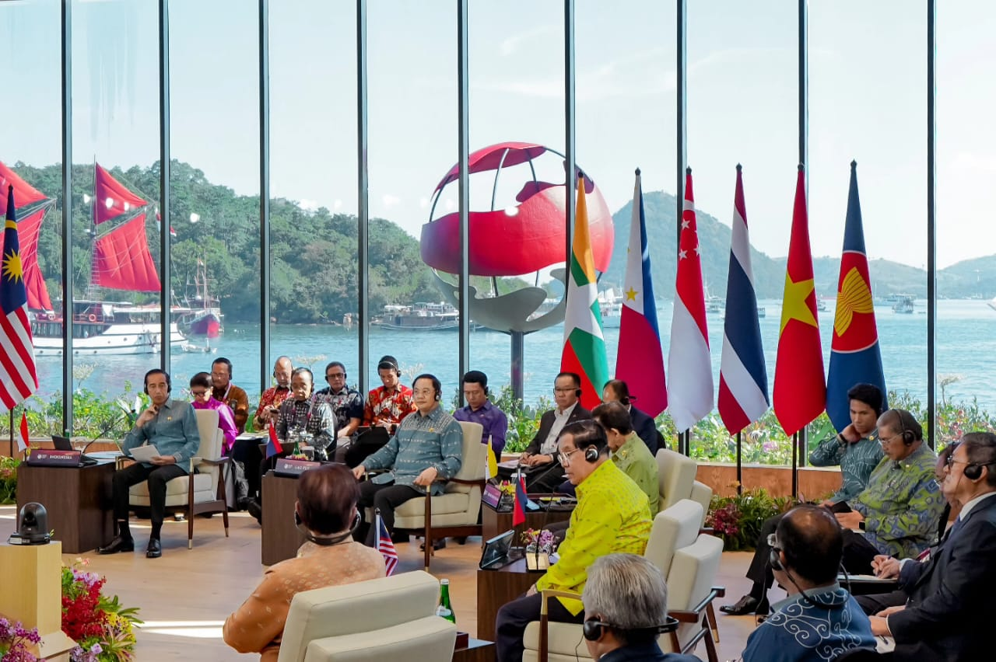

President Jokowi chaired the Retreat session of the 42nd ASEAN Summit in 2023, Thursday (11/05/2023), at Meruorah Hotel, Labuan Bajo. (Photo: Presidential Secretariat’s Press, Media, and Information Bureau)

